**Pooling-Invariant Image Feature Learning**

## Yangqing Jia UC Berkeley

[jiayq@eecs.berkeley.edu](mailto:jiayq@eecs.berkeley.edu)

## Oriol Vinyals UC Berkeley

[vinyals@eecs.berkeley.edu](mailto:vinyals@eecs.berkeley.edu)

## Trevor Darrell UC Berkeley & ICSI

[trevor@eecs.berkeley.edu](mailto:trevor@eecs.berkeley.edu)

# Abstract

*Unsupervised dictionary learning has been a key com- ponent in state-of-the-art computer vision recognition ar- chitectures. While highly effective methods exist for patch- based dictionary learning, these methods may learn redun- dant features after the pooling stage in a given early vi- sion architecture. In this paper, we offer a novel dictionary learning scheme to efficiently take into account the invari- ance of learned features after the spatial pooling stage. The algorithm is built on simple clustering, and thus enjoys ef- ficiency and scalability. We discuss the underlying mecha- nism that justifies the use of clustering algorithms, and em- pirically show that the algorithm finds better dictionaries than patch-based methods with the same dictionary size.*

# Introduction

In the recent decade local patch-based, spatially pooled feature extraction pipelines have been shown to provide good image features for classification. Methods following such a pipeline usually start from densely extracted local image patches (either normalized raw pixel values or hand- crafted descriptors such as SIFT or HOG), and perform dic- tionary learning to obtain a dictionary of codes (filters). The patches are then encoded into an over-complete representa- tion using various algorithms such as sparse coding [14, 17] and simple inner product with a non-linear post-processing [4, 10]. After encoding, spatial pooling with average or max operations are carried out to form a global image represen- tation [19, 1]. The encoding and pooling pipeline can be stacked to produce a final feature vector, which is then used to predict the labels for the images usually via a linear clas- sifier.

There is an abundance of literature on single-layered net- works for unsupervised feature encoding. Dictionary learn- ing algorithms have been discussed to find a set of basis that reconstructs local image patches or descriptors well [13, 4], and several encoding methods have been proposed to map the original data to a high-dimensional space that empha- sizes certain properties, such as sparsity [14, 19, 20] or lo-

cality [17].

A particularly interesting finding in the recent papers [3, 15, 4, 16] is that very simple patch-based dictionary learning algorithms like K-means or random selection, combined with feed-forward encoding methods with a naive nonlinearity, produces state-of-the-art performance on var- ious datasets. Explanation of such phenomenon often fo- cuses on the local image patch statistics, such as the fre- quency selectivity of random samples [16].

A potential problem with such patch-based learning methods is that it may learn redundant features when we consider the pooling stage, as two codes that are uncorre- lated may become highly correlated after pooling due to the introduction of spatial invariance. While using a larger dic- tionary almost always alleviates this problem, in practice we often want the dictionary to have a limited number of codes due to various reasons. First, feature computation has be- come the dominant factor in the state-of-the-art image clas- sification pipelines, even with purely feed-forward methods (*e.g*., threshold encoding [4]) or speedup algorithms (*e.g*., LLC [17]). Second, reasonably sized dictionary helps to more easily learn further tasks that depends on the encoded features; this is especially true when we have more than one coding-pooling stage such as stacked deep networks, or when one applies more complex pooling stages such as second-order pooling [2], as a large encoding output would immediately drive up the number of parameters in the next layer.

Thus, it would be beneficial to design a dictionary learn- ing algorithm that takes pooling into consideration and learns a compact dictionary. Prior work on addressing such problem often resorts to convolutional approaches [12, 22]. These methods are usually able to find dictionaries that bear a better level of spatial invariance than patch-based K- means, but are often non-trivial to train when the dictionary size is large, since a convolution operation has to be carried out instead of simple inner products.

In our paper we present a new method that is analogous to the patch-based K-means method for dictionary learning, but takes into account the redundancy that may be intro- duced in the pooling stage. We show how a K-centroids

arXiv:1302.5056v1 [cs.CV] 15 Jan 2013

1

### Input Image

Dense local patches

Encoding

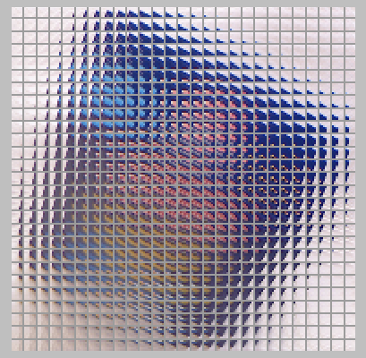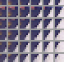

Pooling

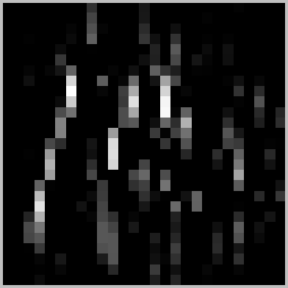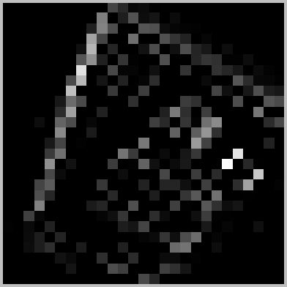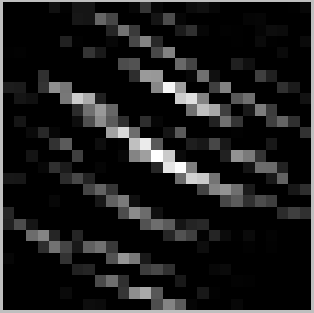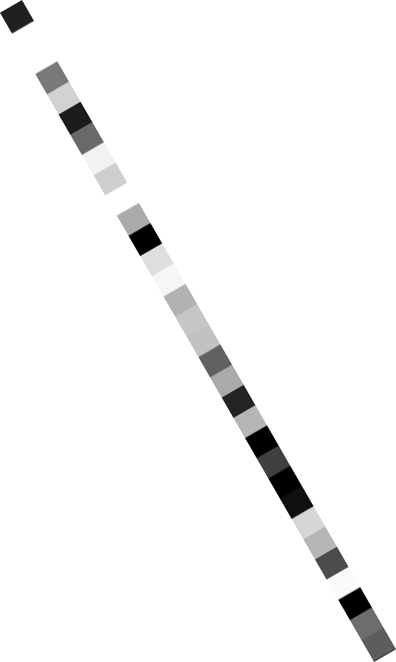

(Codebook)

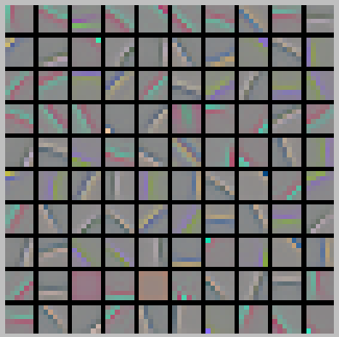

Activation Maps

⌃(·)

### Output Feature

Figure 1: The feature extraction pipeline, composed of dense local patch extraction, encoding, and pooling. Illustrated is the average pooling over the whole image for simplicity, and in practice the pooling can be carried out over finer grids of the image as well as with different operations (such as max).

clustering method applied on the covariance between can- didate codes can efficiently learn pooling invariant repre- sentations. We also show how one can view dictionary learning as a matrix approximation problem, which finds the best approximation to an “oracle” dictionary (which is often very large). It turns out that under this perspective, the performance of various dictionary learning methods can be explained by the recent findings in Nystro¨m subsampling [11, 23].

We will first review the feature extraction pipeline and the effect of pooling on the learned dictionary in Section 2, and then describe the proposed two-stage dictionary learn- ing method in Section 3. The effectiveness of this simple yet effective dictionary learning algorithms on the standard CIFAR-10 and STL benchmark datasets, as well as the fine- grained classification task, in which we show that feature learning plays an important role.

# Background

We illustrate the feature extraction pipeline that is com- posed of encoding dense local patches and pooling encoded features in Figure 1. Specifically, starting with an input im- age **I**, we formally define the encoding and pooling stages as follows.

1. **Coding.** In the coding step, we extract local image patches1, and encode each patch to *K* activation values based on a dictionary of size *K* (learned via a separate dic- tionary learning step). These activations are typically binary (in the case of vector quantization) or continuous (in the case of e.g. sparse coding), and it is generally believed that having an over-complete (*K >* the dimension of patches) dictionary while keeping the activations sparse helps clas- sification, especially when linear classifiers are used in the later steps.

We will mainly focus on what we call the decoupled

1Although we use the term “patches” throughout the paper, the pipeline works with local image descriptors, such as SIFT, as well.

encoding methods, in which the activation of one code does not rely on other codes, such as threshold encod- ing [4], which computes the inner product between **p** and

each code, with a fixed threshold parameter *α*: *fk*(**x**) = max 0*,* **d***Tk* **p** *α* . Such methods have been increasingly popular mainly for their efficiency over coupled encoding

{ − }

methods such as sparse coding, for which a joint optimiza- tion needs to be carried out. Their employment in several deep models (e.g. [10]) also suggests that such simple non- linearity may suffice to learn a good classifier in the later stages.

**Learning the dictionary:** Recently, it has been found that relatively simple dictionary learning and encoding ap- proaches lead to surprisingly good performances [3, 16]. For example, to learn a dictionary = **d**1*,* **d**2*, ,* **d***K* of size *K* from randomly sampled patches = **p**1*,* **p**2*, ,* **p***N* each reshaped as a vector of pixel val- ues, one could simply adopt the K-means algorithm, which aims to minimize the squared distance between each patch and its nearest code: min**D** *N* min*j* **p***i* **d***j* 2. We refer to [3] for a detailed comparison about different dictio- nary learning and encoding algorithms.

{ · · · }

P

D { · · · }

*i*=1

2

Σ ǁ − ǁ

1. **Pooling.** Since the coding result are highly over- complete and highly redundant, the pooling layer aggre- gates the activations over a spatial region of the image to obtain a *K* dimensional vector **x**. Each dimension of the pooled feature **x***i* is obtained by taking the activations of the corresponding code in the given spatial region (also called receptive field in the literature), and performing a prede- fined operator (usually average or max) on the set of activa- tions.

Figure 1 shows an example when average pooling is car- ried out over the whole image. In practice we may define multiple spatial regions per image (such as a regular grid), and the global representation for the image will then be a vector of size *K* times the number of spatial regions.

Since the feature extraction for image classification of- ten involves the spatial pooling stage, the patch-level dic-

4*.*0

Before pooling, *⇢* = 0.394

After pooling, *⇢* = 0.887

6

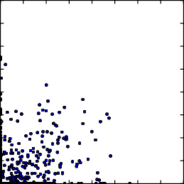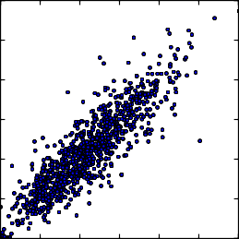

4*.*0

Before pooling, *⇢* = 0.150

After pooling, *⇢* = 0.576

6

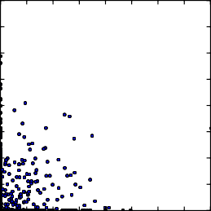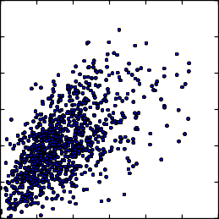

3*.*5

5

3*.*0

4

2*.*5

3*.*5

5

3*.*0

4

2*.*5

2*.*0 3 2*.*0 3

1*.*5

1*.*0

0*.*5

0*.*0

(a)

0*.*0 0*.*5 1*.*0 1*.*5 2*.*0 2*.*5 3*.*0 3*.*5 4*.*0

2

1

00 1 2 3 4 5 6

1*.*5

1*.*0

0*.*5

0*.*0

(b)

0*.*0 0*.*5 1*.*0 1*.*5 2*.*0 2*.*5 3*.*0 3*.*5 4*.*0

2

1

00 1 2 3 4 5 6

Figure 2: Two codes learned from a patch-based K-means algorithm that produce lowly correlated patch-based responses, but highly correlated responses after pooling. Notice that such phenomenon does not only exist between codes with translational difference (as in (a)), but also between other appearances (such as color in (b)).

tionary learning may not find good dictionaries that produce most informative pooled outputs. In fact, one would reason- ably argue that it doesn’t, one immediate reason being that patch-based dictionary learning algorithms often yield sim- ilar Gabor filters with small translations. Such filters, when pooled over a certain spatial region, produce highly corre- lated responses and lead to redundancy in the feature repre- sentation. Figure 2 shows two such examples, where filters produce uncorrelated patch-based responses but highly cor- related pooled responses.

Convolutional approaches [12, 22] are usually able to find dictionaries that are more spatially invariant than patch- based K-means, but learning may not scale as well as sim- ple clustering algorithms, especially with hundreds or thou- sands of codes. In addition, convolutional approaches may still not solve the problem of inter-code invariance: for ex- ample, the response of a colored edge filter might have high correlation with that of a gray scale edge filter, and such correlation could not be modeled by spatial invariance.

Note that the large dictionary is only used during the feature learning time - after this, for each input image, we only need to encode local patches with the selected, relatively smaller dictionary, not any more expensive than existing feature ex- traction methods.

#### 3.1. Feature Selection with Affinity Propagation

The first step of our algorithm is identical to the patch- based K-means algorithm with a starting dictionary size *M* . After this, we can sample a set of image super-patches of the same as the pooling regions, and obtain the *M* dimen- sional pooled features from them. Randomly sampling a large number of pooled features in this way allows us to analyze the pairwise similarities between the codes in the starting dictionary in a post-pooling fashion. We would then like to find a *K*-dimensional subspace that best represents the *M* pooled features. Specifically, the similarity between two pooled dimensions (which correspond to two codes in the starting dictionary) *i* and code *j* as

√*C*

# Pooling-Invariant Dictionary Learning

2*Cij*

(1)

We are interested in designing a simple yet effective dic-

*s*(*i, j*) =

*ii*

2

*Cjj*

−

tionary learning algorithm that takes into consideration the pooling stage of the feature extraction pipeline, and that models the general invariances among the pooled features. Observing the effectiveness of clustering methods in dictio- nary learning, we propose to learn a final dictionary of size *K* in two stages: first, we adopt the patch-based K-means algorithm to learn a more over-complete starting dictionary of size *M* (*M > K*); we then perform encoding and pool- ing using the dictionary, learn the final, smaller dictionary of size *K* from the statistics of the *M* pooled features.

The motivation of such idea is that K-means is a highly parallelizable algorithm that could be scaled up by simply sharding the data, allowing us to have an efficient algorithm for dictionary learning. Using a starting dictionary allows us to preserve most information on the patch-level, and the second step prunes away the redundancy due to pooling.

where **C** is the covariance matrix computed from the ran- dom sample of pooled features. We note that this is equiv- alent to the negative Euclidean distance between the coded output *i* and the coded output *j* when the outputs are nor- malized to have zero mean and standard deviation 1. We then use affinity propagation [9], which is a version of the K-centroids algorithm, to select centroids from existing fea- tures. Intuitively, codes that produce redundant pooled out- put (such as translated versions of the same code) would have high similarity between them, and only one exemplar would be chosen by the algorithm.

Specifically, affinity propagation finds centroids from a set of candidates where pairwise similarity *s*(*i, j*) (1

≤

*i, j M* ) can be computed. It iteratively updates two terms, the “responsibility” *r*(*i, j*) and the “availability” *a*(*i, j*) via a message passing method following such rules

≤

[9]:

*r*(*i, k*) ← *s*(*i, k*) − max{*a*(*i, kj*) + *s*(*i, kj*)} (2)

the patches P as the dictionary, leading to a *N* -dimensional space and an *N* × *N* covariance matrix **C***P* . Since in prac-

*kt k*

tice we always assume a budget on the dictionary size, the

goal is to find a dictionary D of size *K*, which yields a *K*-

*a*(*i, k*) ← min{0*, r*(*k, k*) + Σ*it ∈/{i,k}* max{0*, r*(*ij, k*)}}

D

dimensional space and a covariance matrix **C***D*. The ap-

(if *i k*) (3)

proximation to the “oracle” encoded space using could

then be computed as:

*a*(*k, k*) ← Σ*it*

*D*

*k* max{0*, r*(*ij, k*)} (4)

**C***P* ≈ **C***PD*

**C**+**C***DP*

(6)

Upon convergence, the centroid that represents any candi- date *i* is given by arg max*k*(*a*(*i, k*)+ *r*(*i, k*)), and the set of centroids S is obtained by

S = {*k*|∃*i, k* s.t. *k* = arg max(*a*(*i, kj*) + *r*(*i, kj*))} (5)

*tk*

And we refer to [9] for details about the nature of such mes- sage passing algorithms.

#### 3.2. Visualization of Selected Filters

To visually show what codes are selected by affinity propagation, we applied our approach to the CIFAR-10 dataset by first training an over-complete dictionary of 3200 codes, and then performing affinity propagation on the 3200-dimensional pooled features to obtain 256 centroids, which we visualize in Figure 3. Translational invariance appears to be the most dominant factor, as many clusters contain translated versions of the same Gabor like code, es- pecially for gray scale codes. On the other hand, clusters capture more than translation: clusters such as column 5 focus on finding the contrasting colors more than finding edges of exactly the same angle, and clusters such as the last column finds invariant edges of varied color. We note that the selected codes are not necessarily centered (which is the case for convolutional approaches), as the centroids are se- lected solely from the pooled response covariance statistics, which does not explicitly favor centered patches.

# Why Does Clustering Work?

We will briefly discuss the reason why simple clustering algorithms work well in finding a good dictionary. Essen- tially, given a dictionary **D** of size *K* and specifications on the encoding and pooling operations, the feature extraction pipeline could be viewed as a projection from the original raw image pixels to the pooled feature space R*K* . Note that this space does not degenerate since the feature extraction is highly nonlinear, and one could also view this from a kernel perspective as defining a specific kernel between images. Then, one way to evaluate the information contained in this embedded feature space is to use the covariance matrix **C** of the output features, which plays the dual role of the kernel

matrix between the encoded patches.

where **C***PD* is the covariance matrix between the features extracted by and the one extracted by , and **C**+ denotes

the matrix pseudo-inverse.

P D

Note that such explanation works for both the before- pooling case and the after-pooling case. The dictionary learning algorithm can then be thought as finding a dictio-

nary that approximates **C***P* best. Interestingly, this could be thought as a form of the Nystro¨m method that subsam-

ples subsets of the matrix columns for approximation. The Nystro¨m method has been used to approximate large matri- ces for spectral clustering [8], and here enables us to explain the mechanism of dictionary learning. Recent research in the machine learning field, notably [11], supports the re-

cent empirical observations in vision: first, it is known that uniformly sampling the columns of the matrix **C***P* already works well in reconstruction, which explains the good per-

formance of random patches in feature learning [16]; sec- ond, theoretical results [11, 23] have shown that clustering algorithms works particularly better than other methods as a data-driven way in finding good subsets to approximate the original matrix, justifying the use of clustering in the dictionary learning works.

In the patch-based dictionary learning, clustering could be directly applied on the set of patches (*i.e*. the largest dic- tionary in the limit). When we consider pooling, though, using all the patches becomes non-trivial, since we need to compute pooled features using each patch as a code, which is computationally overwhelming. Thus, a reasonable ap- proach to consider is to first find a subset of all the patches using patch-based clustering (although this “subset” is still larger than our final dictionary size), and perform clustering on the pooled outputs of this subset only, which leads to the proposed algorithm. The performance of the algorithm is then supported by the Nystro¨m theory above.

Based on the matrix approximation explanation, we fur- ther reshape our selected features to match the distribution in the higher-dimensional space corresponding to the start- ing dictionary. After selecting *K* centroids denoted by sub-

set S, we can group the original *M* × *M* covariance matrix

as

**C** = Σ**C***SS* **C***SS*¯Σ *,* **W** = Σ**C***SS* Σ (7)

**C***S*¯*S* **C***S*¯*S*¯

**C***S*¯*S*

Considering that larger dictionaries almost always in- creases performance [20], and in the limit one could use all

where **C***SS*¯ denotes the covariance between the subset S

and the subset S¯ and so on. We then approximate the origi-

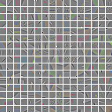



Figure 3: Visualization of the learned codes. Left: the selected subset of 256 centroids from an original set of 3200 codes. Right: The similarity between each centroid and the other codes in its cluster. For each column, the first code is the selected centroid, and the remaining codes are in the same cluster represented by it. Notice that while translational invariance is the most dominant factor, our algorithm does find invariances beyond that (e.g., notice the different colors on the last column). Best viewed in color.

nal high-dimensional covariance matrix as

**C** ≈ **WC**+ **W***T* (8)

*SS*

More importantly, given the pooled outputs **x***S* using the selected filters, the high-dimensional feature could be ap-

proximated by

always yields non-zero coefficients for all the dimensions. Linearly combining the codes does not work either, due to the nonlinear nature of the encoding algorithm. However, as we will show in Section 5.3, results with PCA show that a larger starting dictionary almost always help performance even when the feature is then reduced to a lower dimen- sional space of the same size as a smaller dictionary, which

**x** ≈ **Ax***S ,* where **A** = **WC***−*1

*SS*

(9)

justifies the use of matrix approximation to explain the dic- tionary learning behavior.

Notice that the implicit dimensionality of the data is still no

larger than the number *K* of selected codes, so we can apply SVD on the matrix **A** as **A** = **UΛV** where **Λ** is a *K K* diagonal matrix and **U** is a *M K* column-wise orthonor- mal matrix, and compute the low-dimensional feature (with a little abuse of terminology) as

×

×

**x**¯*S* = **ΛVx***S* (10)

The *K K* transform matrix **ΛV** could be pre-computed during feature selection, and imposes minimum overhead during the actual feature extraction. This transform does not change the dimensionality or the rank of the data, and only changes the shape of the underlying data distribution. In practice, we found the transformed data yields a slightly better performance than the untransformed data when com- bined with a linear SVM with *L*2 regularization.

×

If we simply would like to find a low-dimensional rep- resentation from the *M* -dimensional pooled features, one would naturally choose PCA to find the *K* most significant projections:

**C** ≈ **U***K***Λ***K***U***TK* (11)

where the *M K* matrix *UK* contains the eigenvectors and the *K K* diagonal matrix **Λ***K* contains the eigenvalues. The low-dimensional features are then computed as **x***K* =

×

×

**U***TK* **x**.

We note that while this guarantees the best *K*-

dimensional approximation, it does not help in our task since the number of filters are not reduced, as PCA almost

# Experiments

We apply our pooling-invariant dictionary learning (PDL) algorithm on several benchmark tasks, including the CIFAR-10 and STL datasets on which performance can be systematically analyzed, and the fine-grained classification task of classifying bird species, on which we show that fea- ture learning provides a significant performance gain com- pared to conventional methods.

#### CIFAR-10 and STL

The CIFAR-102 and the STL3 datasets are extensively used to analyze the behavior of feature extraction pipelines. CIFAR-10 contains a large number of training and testing data, while STL contains a very small amount of training data and a large amount of unlabeled images. As our algo- rithm works with any encoding and pooling operations, we adopted the standard setting usually carried on the dataset: extracting local 6 6 patches with mean subtracted and con- trast normalized, whitening the patches with ZCA, and then train the dictionary with normalized K-means. The features are then encoded using one-sided threshold encoding with *α* = 0*.*25 and average pooled over the four quadrants (2 2) of the image. For STL, we followed [5] and resized them to

×

×

32 32. For the PDL algorithm, instead of learning a dif-

×

ferent set of codes for each pooling quadrant, we learn an

2[http://www.cs.toronto.edu/˜kriz/cifar.html](http://www.cs.toronto.edu/%7Ekriz/cifar.html) 3[http://www.stanford.edu/˜acoates/stl10/](http://www.stanford.edu/%7Eacoates/stl10/), [3]

*ρ* = 0.282

4*.*0

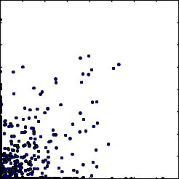

3*.*5

*ρ* = 0.756

6

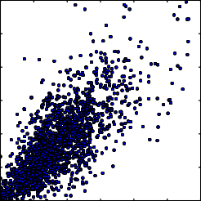

*ρ* = 0.165

6

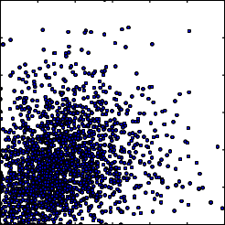

Eigenvalues and Approximation

6 eigval

5 5

eigval pca

3*.*0

4 4

2*.*5

eigval ap

4

2*.*0 3 3 2

1*.*5

2 2

0

1*.*0

0*.*5

0*.*0

0*.*0

0*.*5 1*.*0 1*.*5 2*.*0 2*.*5 3*.*0 3*.*5 4*.*0

1

00 1 2 3 4 5 6

1

00 1 2 3 4 5 6

−2

0 100 200 300 400 500 600

(a) (b) (c) (d)

Figure 4: (a)-(c): The filter responses before and after pooling: (a) before pooling, between codes in the same cluster (correlation *ρ* = 0*.*282), (b) after pooling, between codes in the same cluster (*ρ* = 0*.*756), and (c) after pooling, between the selected centroids (*ρ* = 0*.*165), (d): the approximation of the eigenvalues using the Nystro¨m method.

identical set of codes in general for pooling the coded out- puts. For all experiments, we carry out 5 independent runs and take the mean accuracy to report here.

#### Statistics for Feature Selection

We first verify whether the learned codes capture the pooling invariance as we claimed in the previous section. To this end, we start from the selected features in Section 3.2, and randomly sample three types of filter responses:

(a) pairwise filter responses *before pooling* between codes in the same cluster, (b) pairwise filter responses *after pool-*

73*.*0

72*.*5

|  |  |  |  |  |  |  |
| --- | --- | --- | --- | --- | --- | --- |
|  |  |  |  |  | |  |
|  |  |  |  |  | |  |
|  |  |  |  |  | |  |
|  |  |  |  |  | |  |
|  |  |  |  |  | |  |
|  |  |  |  |  | |  |
|  |  |  |  |  | |  |
|  |  |  |  |  | PDL  PCA | |
|  |  |  |  |  |

72*.*0

71*.*5

Testing accuracy

71*.*0

70*.*5

70*.*0

69*.*5

69*.*0

68*.*5

200 400 800 1600 3200

Starting dictionary size

*ing* between codes in the same cluster, and (c) pairwise fil- ter responses after pooling between the selected centroids. The distribution of such responses are plotted in Figure 4. The result verifies our conjecture well: first, codes that pro- duce uncorrelated responses before pooling may become correlated after the pooling stage (comparing 4(a) and 4(b)), which could effectively be identified by the affinity propa- gation algorithm; second, by explicitly taking into consider- ation the pooling behavior, we are able to select a subset of the features whose responses are lowly correlated (compare 4(b) and 4(c)), which helps preserve more information with a fixed number of codes.

Figure 4(d) shows the eigenvalues of the original covari- ance matrix and those of the approximated covariance ma- trix, using the same setting as in the previous subsection4. The approximation captures the largest eigenvalues of the original covariance matrix well, while dropping at a higher rate for smaller eigenvalues.

#### Classification Performances

Figure 5 shows the relative improvement obtained on CIFAR-10, when we use a budgeted dictionary of size 200, but perform feature selection from a larger dictionary as in- dicated by the X axis. The PCA performance is also in- cluded in the figure as a loose upper bound of the feature

4Note that since we only select 256 features, the number of nonzero eigenvalues is 256 for the approximation.

Figure 5: Performance improvement on CIFAR when using different starting dictionary sizes and a final dictionary of size 200. Shaded areas denote the standard deviation over different runs. Note that the x-axis is in log scale.

selection performance. Learning the dictionary with our feature selection method consistently increases the perfor- mance as the size of the original dictionary increases, and is able to get about 70% the performance gain as obtained by PCA (again, notice that PCA still requires all the codes to be used, thus does not save feature extraction time).

The detailed performance of our algorithm on the two datasets, using different starting and final dictionary sizes, is visualized in Figure 6. Table 1 summarizes the accu- racy values of two particular cases - final dictionary sizes of 200 and 1600 respectively. Note that our goal is not to get the best overall performance - as performance always goes up when we use more codes. Rather, we focus on how much gain the pooling-aware dictionary learning gets, given a fixed dictionary size as the budget. Figure 7 shows the performance of the various settings, using PCA to reduce the dimensionality instead of PDL. As we stated in the pre- vious section, this serves as an upper bound of the feature selection algorithms.

Overall, considering the pooled feature statistics always help us to find better dictionaries, especially when only

80 Table 1: Classification Accuracy on the CIFAR-10 and STL

K-means

2x PDL

4x PDL

8x PDL

78 datasets under different budgets.

76

Accuracy

74

72

70

68

66

100 200 400 800 1600 3200

Final Dictionary Size

59

K-means

2x PDL

4x PDL

8x PDL

58

57

56

Accuracy

55

54

53

52

51

50

100 200 400 800 1600 3200

Final Dictionary Size

Figure 6: Accuracy values on the CIFAR-10 (top) and STL (bottom) datasets under different final dictionary size. “nx PDL” means learning the dictionary from a starting dictio- nary that is n times larger.

|  |  |  |
| --- | --- | --- |
| Task | Learning Method | Accuracy |
|  | K-means | 69.02 |
| CIFAR-10 | 2x PDL | 70.54 (+1.52) |
| 200 codes | 4x PDL | 71.18 (+2.16) |
|  | 8x PDL | 71.49 (+2.47) |
| CIFAR-10 | K-means | 77.97 |
| 1600 codes | 2x PDL | 78.71 (+0.74) |
|  | K-means | 53.22 |
| STL | 2x PDL | 54.57 (+1.35) |
| 200 codes | 4x PDL | 55.53 (+2.31) |
|  | 8x PDL | 55.52 (+2.30) |
| STL | K-means | 58.16 |
| 1600 codes | 2x PDL | 58.28 (+0.12) |

of Figure 4), one can infer that the representations obtained with a budget would have a correspondingly bounded per- formance when combined with linear SVMs. In this paper we have focused on analyzing unsupervised approaches. In- corporating weakly supervised information to guide feature learning / selection or learning multiple layers of feature extraction would be particularly interesting, and would be a possible future direction.

#### Fine-grained Classification

80

78

76

Accuracy

74

72

70

68

66

100 200 400 800 1600 3200

Final Dictionary Size

59

58

8x PCA

K-means

2x PCA

4x PCA

K-means 2x PCA

4x PCA

8x PCA

57

56

Accuracy

55

54

53

52

51

50

100 200 400 800 1600 3200

Final Dictionary Size

To show the performance of the feature learning algo- rithm in the real-world image classification tasks, we tested the performance of our algorithm on the fine-grained clas- sification task, using the 2011 Caltech-UCSD Birds dataset [18]5. Classification of file-grained categories poses a sig- nificant challenge for the contemporary vision algorithms, as such classification tasks usually requires the identifica-

Figure 7: Accuracy values using PCA to reduce the dimen- sionality to the same as that PDL uses, as an accuracy upper bound for the performance of PDL.

a small dictionary is allowed for classification. Choosing from a larger starting dictionary helps increasing perfor- mance, although such effect saturates when the dictionary size is much larger than the target size. For the STL dataset, a large starting dictionary may lessen the performance gain (Figure 6(b)). We infer the reason to be that feature selec- tion is more prone to local optimum, and the small train- ing data of STL may cause the performance to be sensi- tive to suboptimal codebook choices. However, in general the codebook learned by PDL is consistently better than its patch-based counterpart.

Finally, we note that due to the heavy-tailed nature of the encoded and pooled features (see the eigendecomposition

tion of localized appearances like “birds with yellow spotted feather on the belly” which is hard to capture using manu- ally designed features. Recent work on fine-grained classifi- cation usually focuses on the localization of parts [7, 24, 6], and still uses manually designed features. Yao et al. [21] proposed to use a template-based approach for more pow- erful features, but the approach may be difficult to scale as the number of templates grow larger6. In addition, due to the lack of training data in fine-grained classification tasks, whether supervised feature learning is useful or not is un- clear yet.

We performed classification on all the 200 bird species provided. For the image pre-processing we followed the same setting as [24, 21] by cropping the images to be cen-

5[http://www.vision.caltech.edu/visipedia/](http://www.vision.caltech.edu/visipedia/CUB-200-2011.html)

[CUB-200-2011.html](http://www.vision.caltech.edu/visipedia/CUB-200-2011.html)

6Due to computation complexity, some early work such as [7, 21] do not scale up well, and only reported performance on subsets of the whole data [personal communication].

Table 2: Classification Accuracy on the 2011 Caltech- UCSD Birds dataset.

|  |  |
| --- | --- |
| Method | Accuracy |
| BoW SIFT Baseline [24] | 18.60 |
| Pose Pooling + linear SVM [24] | 24.21 |
| Pose Pooling + *χ*2 SVM [24] | 28.18 |
| K-means + linear SVM (as in [5]) | 38.17 |
| PDL + linear SVM | **38.91** |

tered on the birds using 1.5 the size of the provided bound- ing boxes. We then resized each cropped image to 128 128 to avoid any artifact that may be introduced by the varying number of local features. The training data are expanded by simply mirroring each training image. Then, we extract

×

×

5 5 local whitened patches as we did for CIFAR-10, en- coded them using threshold encoding with a dictionary of size 1600, and performed 4 4 max pooling since the bird images are larger than those from CIFAR and STL. The dic- tionary is learned using our feature extraction pipeline, from an original set of 3200 patch-based clustering centers.

×

×

Our classification results, together with previous state- of-the-art baselines from [24], are reported in Table 2. It is somewhat surprising to observe that feature learning pro- vides a significant performance boost in this case, indicating that in addition to part localization (which has been the fo- cus of fine-grained classification), learning appropriate fea- tures / descriptors to represent local appearances may be a major factor in fine-grained classification, possibly due to the subtle appearance changes for such tasks. As we have shown here, even simple and fully unsupervised fea- ture learning algorithms such as K-means and PDL could lead to significant accuracy improvement, and we hope this would inspire further advancement in the fine-grained clas- sification research.

# Conclusion

We have proposed a novel algorithm to efficiently take into account the invariance of learned features after the spa- tial pooling stage. The algorithm is empirically shown to identify redundancy between codes learned in a patch-based way, and yields dictionaries that produces better classifica- tion accuracy than simple patch-based approaches. To ex- plain the performance gain we proposed to take a matrix approximation view of the dictionary learning, and show the close connection between the proposed methods and the Nystro¨m method. The proposed method does not introduce overheads during classification time, and could be easily “plugged in” to the existing image classification pipelines.

# References

1. Y Boureau, F Bach, Y LeCun, and J Ponce. Learning mid-level features for recognition. In *CVPR*, 2010. 1
2. J Carreira, R Caseiro, J Batista, and C Sminchisescu. Semantic seg- mentation with second-order pooling. In *ECCV*, 2012. 1
3. A Coates, H Lee, and A Ng. An analysis of single-layer networks in unsupervised feature learning. In *AISTATS*, 2011. 1, 2, 5
4. A Coates and A Ng. The importance of encoding versus training with sparse coding and vector quantization. In *ICML*, 2011. 1, 2
5. A Coates and AY Ng. Selecting receptive fields in deep networks. In

*NIPS*, 2011. 5, 8

1. K Duan, D Parikh, D Crandall, and K Grauman. Discovering local- ized attributes for fine-grained recognition. In *CVPR*, 2012. 7
2. R Farrell, O Oza, N Zhang, VI Morariu, T Darrell, and LS Davis. Birdlets: Subordinate categorization using volumetric primitives and pose-normalized appearance. In *CVPR*, 2011. 7
3. C Fowlkes, S Belongie, F Chung, and J Malik. Spectral grouping using the nystrom method. *IEEE TPAMI*, 26(2):214–225, 2004. 4
4. BJ Frey and D Dueck. Clustering by passing messages between data points. *Science*, 315(5814):972–976, 2007. 3, 4
5. A Krizhevsky, I Sutskever, and GE Hinton. Imagenet classification with deep convolutional neural networks. In *NIPS*, 2012. 1, 2
6. S Kumar, M Mohri, and A Talwalkar. Sampling methods for the nystro¨m method. *JMLR*, 13(Apr):981–1006, 2012. 2, 4
7. H Lee, R Grosse, R Ranganath, and AY Ng. Convolutional deep be- lief networks for scalable unsupervised learning of hierarchical rep- resentations. In *ICML*, 2009. 1, 3
8. J Mairal, F Bach, J Ponce, and G Sapiro. Online learning for matrix factorization and sparse coding. *JMLR*, 11:19–60, 2010. 1
9. B Olshausen and DJ Field. Sparse coding with an overcomplete basis set: a strategy employed by V1? *Vision research*, 37(23):3311–3325, 1997. 1
10. R Rigamonti, MA Brown, and V Lepetit. Are sparse representations really relevant for image classification? In *CVPR*, 2011. 1
11. A Saxe, PW Koh, Z Chen, M Bhand, B Suresh, and A Ng. On random weights and unsupervised feature learning. In *ICML*, 2011. 1, 2, 4
12. J Wang, J Yang, K Yu, F Lv, T Huang, and Y Gong. Locality- constrained linear coding for image classification. In *CVPR*, 2010.  1
13. P Welinder, S Branson, T Mita, C Wah, F Schroff, S Belongie, and P Perona. Caltech-UCSD Birds 200. Technical Report CNS-TR- 2010-001, Caltech, 2010. 7
14. J Yang, K Yu, and Y Gong. Linear spatial pyramid matching using sparse coding for image classification. In *CVPR*, 2009. 1
15. J Yang, K Yu, and T Huang. Efficient highly over-complete sparse coding using a mixture model. In *ECCV*, 2010. 1, 4
16. B Yao, G Bradski, and L Fei-Fei. A codebook-free and annotation- free approach for fine-grained image categorization. In *CVPR*, 2012. 7
17. MD Zeiler, D Krishnan, GW Taylor, and R Fergus. Deconvolutional networks. In *CVPR*, 2010. 1, 3
18. K Zhang, IW Tsang, and JT Kwok. Improved nystro¨m low-rank approximation and error analysis. In *ICML*, 2008. 2, 4
19. N Zhang, R Farrell, and T Darrell. Pose pooling kernels for sub- category recognition. In *CVPR*, 2012. 7, 8